**Week 2 : SL4J Logging Exercises**

**Exercise 1 : Logging Error Messages and Warning levels**

**SUPERSET ID : 6399056**

**LoggingExample.java**

import org.slf4j.Logger;

import org.slf4j.LoggerFactory;

public class LoggingExample {

private static final Logger logger = LoggerFactory.getLogger(LoggingExample.class);

public static void main(String[] args) {

logger.error("This is an error message");

logger.warn("This is a warning message");

}

}

**Pom.xml**

<dependencies>

<dependency>

<groupId>org.slf4j</groupId>

<artifactId>slf4j-api</artifactId>

<version>1.7.30</version>

</dependency>

<dependency>

<groupId>ch.qos.logback</groupId>

<artifactId>logback-classic</artifactId>

<version>1.2.3</version>

</dependency>

</dependencies>

**OUTPUT**

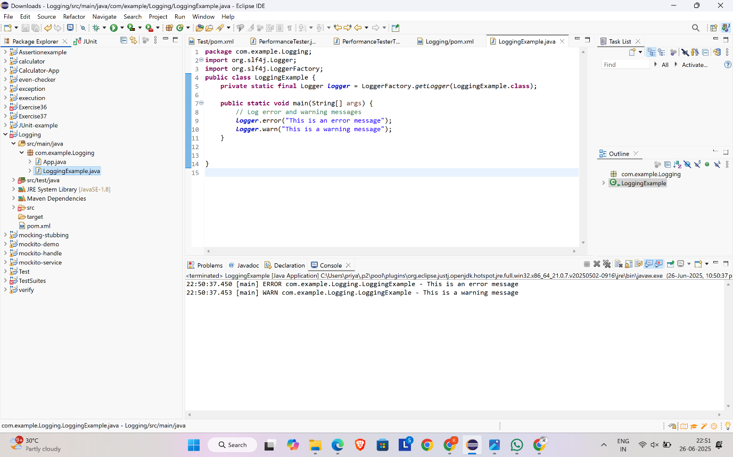

**Exercise 2 : Parameterized Logging**

**ParameterizedLoggingExample.java**

import org.slf4j.Logger;

import org.slf4j.LoggerFactory;

public class ParameterizedLoggingExample {

private static final Logger logger = LoggerFactory.getLogger(ParameterizedLoggingExample.class);

public static void main(String[] args) {

String username = "leona";

int userId = 101;

String status = "active";

logger.info("User '{}' with ID {} is currently {}", username, userId, status);

int failedAttempts = 5;

logger.warn("User '{}' has {} failed login attempts", username, failedAttempts);

String errorMessage = "NullPointerException";

logger.error("An error occurred for user '{}': {}", username, errorMessage);

}

}

**Pom.xml**

<dependencies>

<dependency>

<groupId>org.slf4j</groupId>

<artifactId>slf4j-api</artifactId>

<version>1.7.30</version>

</dependency>

<dependency>

<groupId>ch.qos.logback</groupId>

<artifactId>logback-classic</artifactId>

<version>1.2.3</version>

</dependency>

</dependencies>

**OUTPUT**

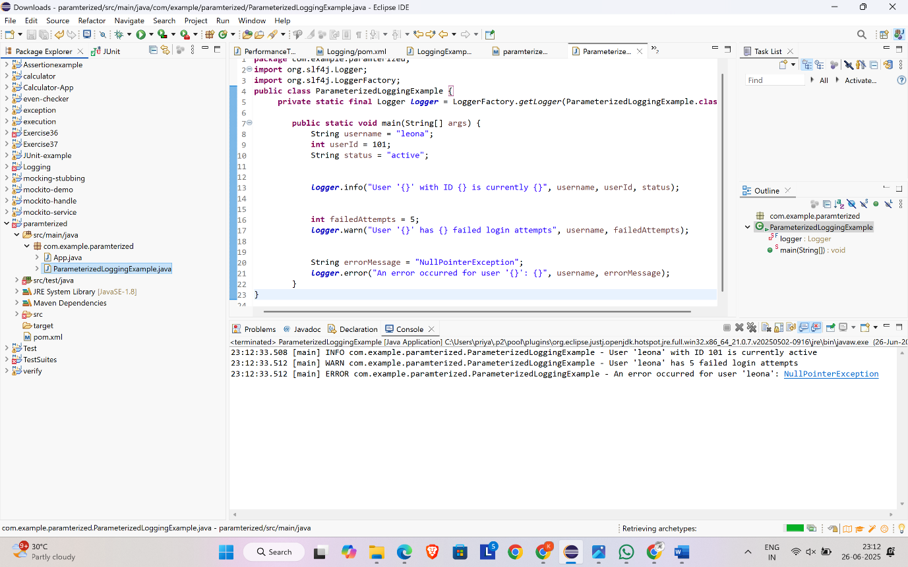

**Exercise 3 : Using Different Appenders**

**Pom.xml**

<dependencies>

<dependency>

<groupId>org.slf4j</groupId>

<artifactId>slf4j-api</artifactId>

<version>1.7.30</version>

</dependency>

<dependency>

<groupId>ch.qos.logback</groupId>

<artifactId>logback-classic</artifactId>

<version>1.2.3</version>

</dependency>

</dependencies>

**Logback.xml**

<configuration>

<appender name="console" class="ch.qos.logback.core.ConsoleAppender">

<encoder>

<pattern>%d{HH:mm:ss.SSS} [%thread] %-5level %logger{36} - %msg%n</pattern>

</encoder>

</appender>

<appender name="file" class="ch.qos.logback.core.FileAppender">

<file>app.log</file>

<append>true</append>

<encoder>

<pattern>%d{HH:mm:ss.SSS} [%thread] %-5level %logger{36} - %msg%n</pattern>

</encoder>

</appender>

<root level="debug">

<appender-ref ref="console" />

<appender-ref ref="file" />

</root>

</configuration>

**MultipleAppenderExample.java**

import org.slf4j.Logger;

import org.slf4j.LoggerFactory;

public class MultipleAppendersExample {

private static final Logger logger = LoggerFactory.getLogger(MultipleAppendersExample.class);

public static void main(String[] args) {

logger.debug("Debug message - helpful for developers");

logger.info("Info message - general application info");

logger.warn("Warning message - something unexpected happened");

logger.error("Error message - something failed");

}

}

**OUTPUT**

